THE ALLY ARCADE
SO MANY WAYS TO HELP

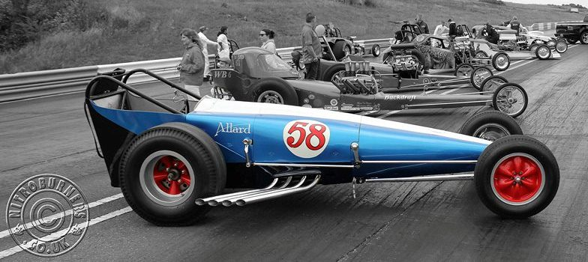
ALL PROFITS GO TOWARDS THE RESTORATION AND RUNNING COSTS

order via brian@allardchrysler.org

Full sized mounted limited edition prints
individually signed by Nick Mason and Alan Allard

Product | Price | Postage and packing
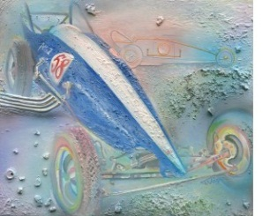  Artist Tommy Vågen | £45.00 | 49.5cm by 44.5cm  UK; £7.00  Overseas prices on request

Product | Price | Postage and packing
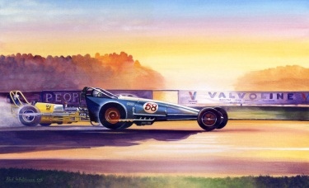  Artist Paul Whitehouse | £45.00 | 67cm by 46cm  UK; £13.00  Overseas prices on request
Full sized un-mounted limited edition prints

Product | Price | Postage and packing
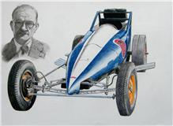  Artist Stuart Taylor | £20.00 | 55cm by 42cm  UK; £3.00  Europe; £3.50  USA; £4.00

Full sized un-mounted limited edition prints commemorating the quickest ever quarter mile run at Santa Pod Raceway
Individually signed by Andy Carter

Product | Price | Postage and packing
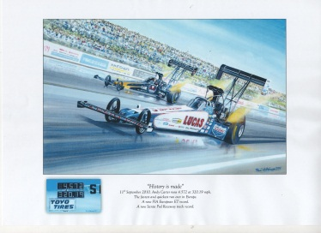  Artist Paul Whitehouse | £20.00 | 24 inches by 17 inches  UK; £5.00  Overseas prices on request

A4 sized prints un-mounted
all £6.00 each or £10 for 2

Product | Price | Postage and packing
Tommy Vågen | £6.00 | UK; £1.50 single  UK; £2.00 for two  UK; £2.50 for four  Overseas prices on request

Product | Price | Postage and packing
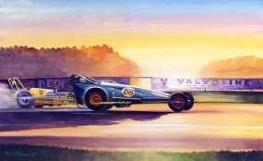 Paul Whitehouse | £6.00 | UK; £1.50 single  UK; £2.00 for two  UK; £2.50 for four  Overseas prices on request

Product | Price | Postage and packing
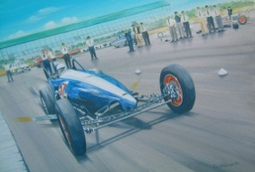Paul Whitehouse | £6.00 | UK; £1.50 single  UK; £2.00 for two  UK; £2.50 for four  Overseas prices on request

Product | Price | Postage and packing
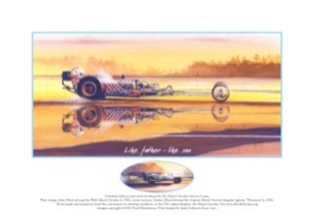Paul Whitehouse | £6.00 | UK; £1.50 single  UK; £2.00 for two  UK; £2.50 for four  Overseas prices on request

Product | Price | Postage and packing
Stuart Taylor | £6.00 | UK; £1.50 single  UK; £2.00 for two  UK; £2.50 for four  Overseas prices on request

Product | Price | Postage and packing
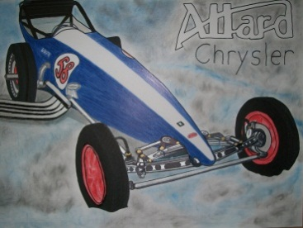 Pedro Keenan | £6.00 | UK; £1.50 single  UK; £2.00 for two  UK; £2.50 for four  Overseas prices on request

NEW
FROM GRAHAM DURBRIDGE

A4 sized un-mounted retro CARtoon prints
£6.00 each or £10 for 2

Product | Price | Postage and packing
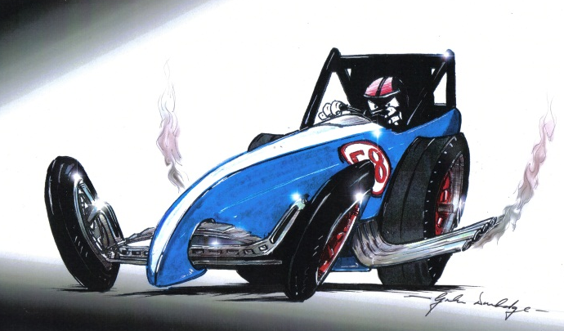 Graham Durbridge | £6.00 | UK; £1.50 single  UK; £2.00 for two  Overseas prices on request

Product | Price | Postage and packing
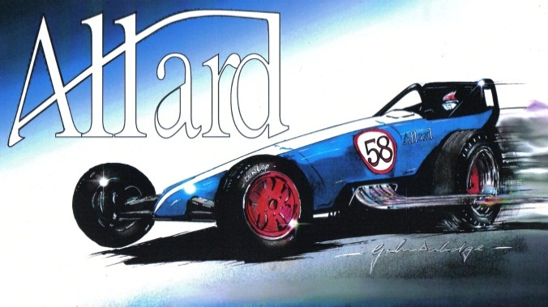 Graham Durbridge | £6.00 | UK; £1.50 single  UK; £2.00 for two  Overseas prices on request

Music CD Special Tribute song by Ked Dieter
Product | Price | Postage and packing
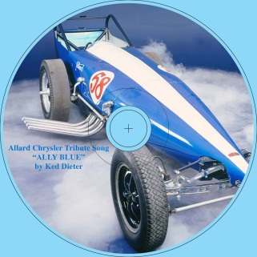 Ked Dieter | £3.50 | UK; £1.50  Overseas; £2.50

Crazy Horses – the history of British drag racing
Product | Price | Postage and packing
Brian Taylor  Individually signed  by the author | £20.00 | UK; £6.00  Overseas prices on request

Special Allard Dragster beer mats 20 for £5.00
Product | Price | Postage and packing
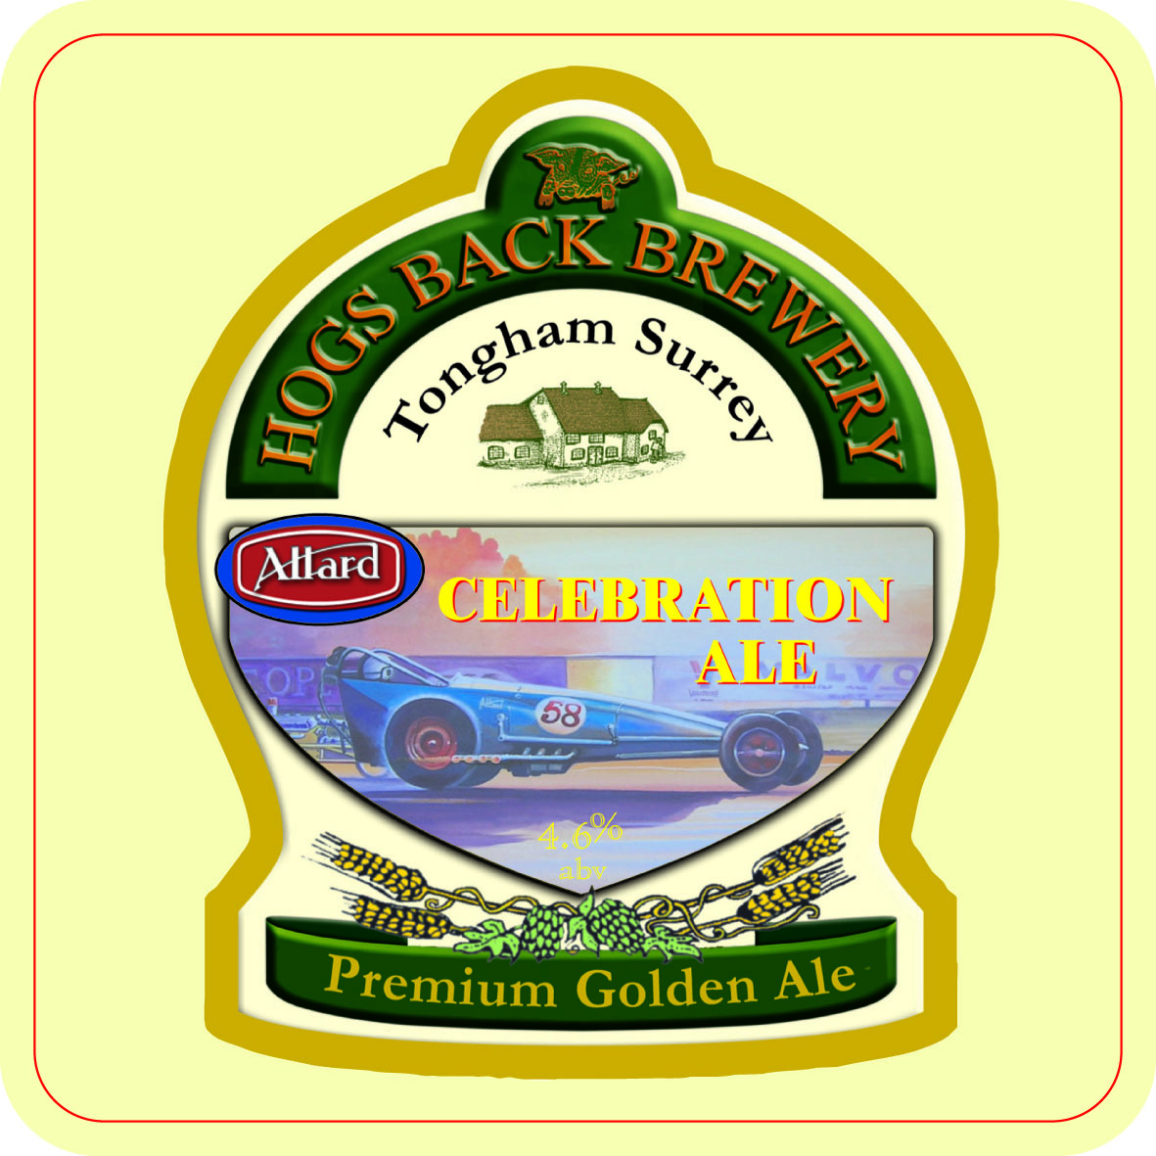 | £5.00 | UK; £3.00  Overseas; £5.00

Signed Linda Vaughan posters
Product | Price | Postage and packing
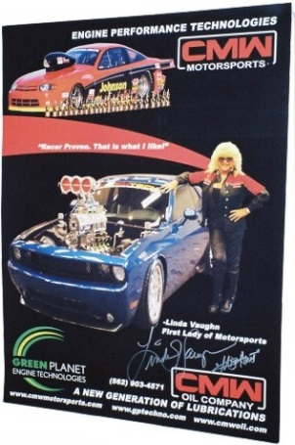  Individually signed  by Linda | £5.00 | 18 inches by 24 inches  UK; £3.00  Europe; £3.50  USA; £4.00

LIMITED EDITION
ONLY 100 made
each one numbered
LUCAS OIL ALLARD CHRYSLER
T-SHIRTS

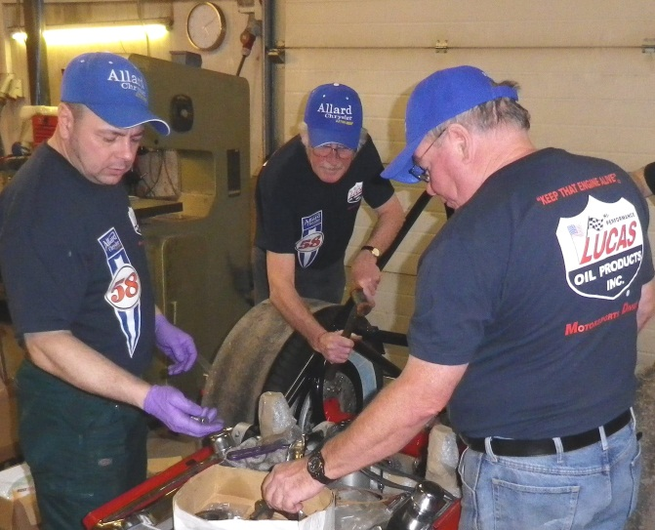
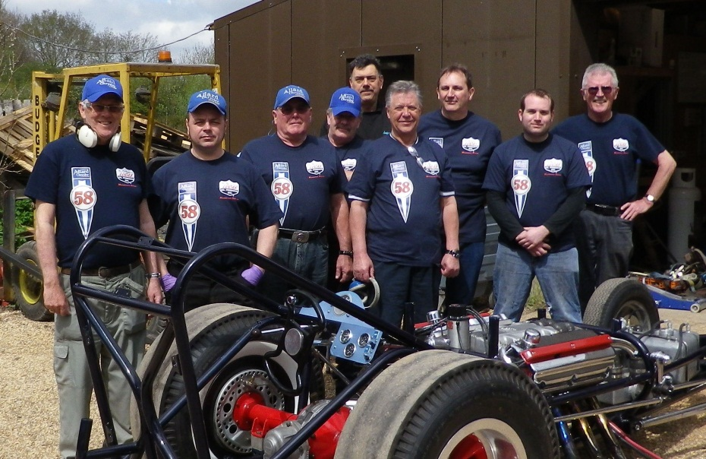

SIZES WHEN AVAILABLE; S, M, L, XL, XXL, XXXL

Product | Price | Postage and packing
Lucas Oil Allard Chrysler T-shirt | £15.00 | UK; £3.00  Overseas; £5.00

